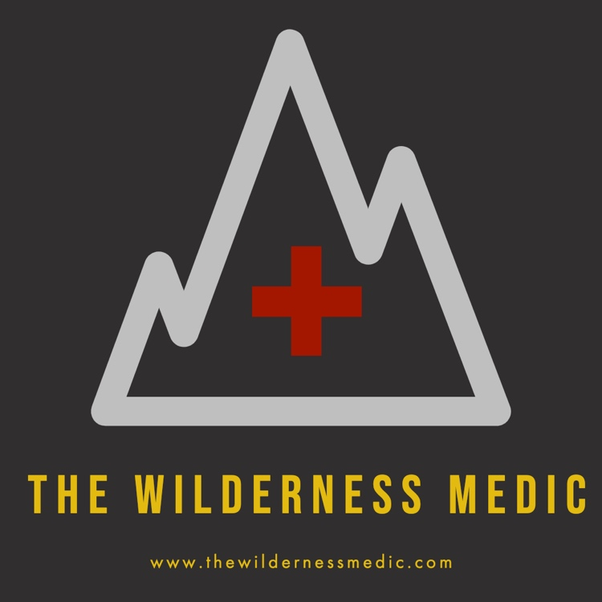

What could I write about?
- Possible Options:

  - Expedition medicine

  - Elective reports

  - Interesting courses- UK or international

  - Humanitarian work

  - Event work

  - Endurance events

  - Travel and adventure

  - Clinical topics e.g. altitude, heat, diarrhoea etc.

- If you have an idea that doesn’t fit one of these topics- please get in touch to discuss it further- we may love it!

- Sample blog entries can be seen online: https://www.thewildernessmedic.com/blog

How long should it be?
- A good length for each blog is between 800-1000 words: longer than this and people’s attention can start to wander!

- If you feel that you have more content than this, there may be an option to do this over a two-part series, however this is not guaranteed.

- Please send all written content as a MS Word document.

What about pictures and videos?
- We love to see your pictures. We usually require a cover photo and up to a maximum of 4-5 further images.

- Please make sure that any pictures you send are your own photos, or, if they are not, that you have permission to share them.

- If you are using someone else’s pictures, please let us know who took them, so that they can be credited on the blog.

- Please send each image to us as a separate file and name each one so that we know what they illustrate.

- If you want to share a video, the best way of doing this is to upload it to YouTube first and then we can embed this onto the site from here.

How should I write my blog?
We aim to create engaging and exciting content that will educate the reader and leave them wanting to read more and further explore the site.
The site is aimed at people like you: students, nurses, paramedics, doctors and outdoor enthusiasts, so bear this in mind when writing your blog.
The content you are writing about will influence your style to an extent. Please try to include the following information somewhere in your text:
- Who are you?
  - Name
  - Background
  - Current Job

- What did you do and why?

- What did you get out of your experience?

- What advice do you have for others?

- If you were traveling or going on an elective, please give us an idea of costs, who prospective students can contact etc.

- If you have done some charity work or other work with an organisation, please write their website/social media so that others can get involved.

Please pay attention to the points below:
- Please check that any such organisations are happy for you to write about your experience prior to submitting any content.

- Please respect patient confidentiality and the confidentiality of other people who you may have been travelling or working with.

- Please anonymise all stories and do not use any patient identifiable information when writing your blog.

- Make sure that you have obtained appropriate consent from anyone that you write about before you submit any content.

- If your blog is focused more on a clinical topic or treatment guidelines, please make sure you have properly referenced any academic literature that you have referred to.

Re-imbursement:
- Please Note: we do not pay for any contributions to the site

- We are however able to provide you with a certificate if needed for your ongoing career development.

Use of your Content
- Any content you submit is subject to thewildernessmedic.com terms and conditions:
https://www.thewildernessmedic.com/terms-and-conditions

What next?
- When you submit your blog as a draft, we will look through it to make sure that it is suitable for the site.
N.B. We reserve the right not to use your blog if we don’t think it suits what we are looking for
- However, assuming that it is ok (which it almost certainly will be) we will look through it and may make some suggestions with regards to content and formatting etc.

- Once you have made any necessary changes we will add it to the queue to be put up on our website.

Please note, there may be delays of several weeks/months between the date of submission and the date that your blog appears online. This is partly due to the fact that we are GPs working in the NHS and may also be abroad on expeditions. There may also be other contributors who are due to have an entry put online before you. If we think that what you have written is too similar to a recent contribution, we may also need to hold on to your blog to use at a later date.

If you have any questions at any point, please email us contact.thewildernessmedic@gmail.com

